

**Woven Together: A System Guide for Stephanie’s Creations**

**Prepared for:  
Dr. Andy Bowman  
MIS 4173 – 601  
East Carolina University  
Spring 2025**

**Prepared by:  
Hannah Clark  
Heather Siler  
Lauren Geis**

Table of Contents

I. 3

Executive Summary with Narrative and Conclusions 3

Company Background & Current Environment 3

Problem Analysis (BPA, BPI, BPR) 3

Proposed System Objectives & Constraints 4

Expected Benefits 5

Context Diagram 5

II. 5

Executive Summary with Narrative and Conclusions 6

Use Case Diagram 6

Supplement Specifications (Non-Functional) 7

III. 10

Executive Summary with Narrative and Conclusions 10

Complete Data Flow Diagram Package 11

Hardware and Software Specification 12

Navigation Diagram 13

Entity Relationship Diagrams 13

Program Plan showing logic and I/Os (IPO Chart with each program listed) 14

Standard Naming Conventions 15

IV. 15

Executive Summary with Narrative and Conclusions 15

Test Plans 15

Training Manual and/or Reference/Procedure Manual 15

Technical Manual 15

V. 15

Executive Summary with Narrative and Conclusions 15

Migration Plan (Business, Technical, People Readiness) 15

Personal Project Assessment (by each member) 15

Lessons Learned during the project (by group) 15

Explanation of challenges, problems and discoveries 15

All Burndown Charts, All Backlogs, All Meeting Logs 15

Any other supporting documentation 15

# I.

## Executive Summary with Narrative and Conclusions

This section provides an overview of Stephanie’s Creations—a homegrown crochet business that began as a hobby during the COVID-19 pandemic and evolved into a passion-driven small business. Section 1 examines the current manual processes and identifies opportunities for improvement through problem analysis, proposed system objectives, constraints, and expected benefits.  
The new system will introduce inventory tracking, sales management, customer data storage, and e-commerce integration, focusing on ease of use, affordability, and scalability. Expected benefits include increased efficiency, improved organization, and enhanced customer service, enabling Stephanie to expand her business and continue her philanthropic efforts.

## Company Background & Current Environment Stephanie began crocheting in 2020 as a hobby during the COVID-19 pandemic. After a prolonged battle with Lyme disease, she found comfort in crafting handmade baby blankets, scarves, and hats. What started as a therapeutic pastime soon became a passion, inspiring her to donate warm clothing to local children in need.

Initially, she planned to launch an Etsy shop, but progress was delayed due to hip replacement surgery. Now fully recovered, Stephanie is eager to establish an online business to share her creations with a wider audience while continuing her philanthropic efforts.

Currently, no formal information system is in place. Order management, inventory tracking, and sales are handled manually, with transactions processed through mobile payment apps. Without a centralized system for managing customer data or automating fulfillment logistics, scalability remains a challenge as the business expands.

## Problem Analysis (BPA, BPI, BPR)

Given Stephanie’s current manual workflow, our team recommends a Business Process Improvement (BPI) approach rather than a full Business Process Reengineering (BPR) overhaul. Since she already has an informal system in place and plans to expand to an online platform, refining her existing operations is more practical than a complete restructuring.

While Business Process Automation (BPA) may be considered in the future to streamline tasks such as customer engagement and predictive inventory tracking, our immediate focus is on enhancing system usability and optimizing core processes for efficiency.

## Proposed System Objectives & Constraints

|  |  |
| --- | --- |
| System Objectives | |
| User-Friendly Interface | The system should be intuitive and easy to navigate, requiring minimal technical knowledge. |
| Inventory Management | Enable efficient tracking of available stock, materials, and finished products. |
| Sales Tracking | Provide tools for recording transactions, monitoring sales trends, and generating reports. |
| Customer Management | Maintain customer details, including order history, preferences, and shipping information, to enhance service. |
| E-commerce Integration | Support seamless integration with online marketplaces to streamline product listings and order processing. |
| Cost-Effective Solution | Minimize recurring costs while maintaining essential functionality. |
| Security & Compliance | Ensure secure storage of customer payment details and personal information in compliance with industry standards. |

|  |  |
| --- | --- |
| System Constraints | |
| Budget Limitations | The system must operate within financial constraints, including hosting, payment processing, and potential subscription fees. |
| Accessibility Considerations | Design must accommodate various visual needs, ensuring readability and ease of use. |
| Limited Technical Expertise | The system should require minimal maintenance and technical knowledge. |
| Scalability | While initially designed for small-scale operations, the system should allow for future expansion. |
| Platform Compatibility | The system should integrate seamlessly with potential websites or e-commerce platforms. |

## Expected Benefits

**Improved Efficiency**

Automating sales, inventory tracking, and order fulfillment will significantly reduce the time and effort required for manual data entry and management. By minimizing repetitive tasks, Stephanie can focus more on creating new products and engaging with customers.

**Scalability**

Implementing a structured system will allow the business to grow without overwhelming manual processes. As demand increases, the system will support additional orders, new product listings, and expanded inventory without requiring extensive operational changes.

**Enhanced Organization**

A centralized platform for order tracking, inventory management, and customer interactions will create a more streamlined and structured workflow. This will reduce errors, prevent stock discrepancies, and ensure that Stephanie always has a clear overview of her business operations.

**Better Customer Service**

By automating fulfillment processes and maintaining accurate records of customer orders and preferences, Stephanie can ensure timely and error-free deliveries. Improved tracking capabilities will also help her provide quick responses to customer inquiries, enhancing overall satisfaction and loyalty.

## Context Diagram

# II.

## Executive Summary with Narrative and Conclusions

In developing Stephanie’s crocheting business website, we have given a lot of attention to making sure that the user’s experience is as smooth and secure as possible. This section describes the system’s non-functional requirements and uses a use case diagram to show how the system interacts.

The use case diagram shows key interactions which include product management, inventory tracking, and payment processing. The non-functional requirements include usability, performance, security, portability, and legal aspects. The system will be user-friendly and easy to navigate. Measures of performance are fast response times and high availability, and security features include data encryption.

## Use Case Diagram

## Supplement Specifications (Non-Functional)

**Operational Specifications**

**1.1 Training and Support:**

**1.1.1 Minimal Training Requirement:** The system shall be designed to minimize end-user training. Stephanie shall be able to perform core functions with no more than 1 hour of initial training.

**1.1.2 Intuitive User Interface:** The user interface shall adhere to established usability guidelines, employing clear labels, consistent navigation, and logical workflows.

**1.1.3 Contextual Help:** Contextual help shall be available for all features, providing on-screen guidance and explanations.

**1.1.4 User Manual and Support Tools:** A comprehensive user manual, FAQ, and video tutorials shall be provided to support Stephanie in using the system.

**1.2 Accessibility:**

**1.2.1 Font and Contrast:** The system shall utilize font sizes and color contrasts that meet WCAG (Web Content Accessibility Guidelines) AA standards.

**1.2.2 Screen Reader Compatibility:** The system shall be compatible with commonly used screen reader software.

**1.2.3 Adjustable Font Sizes:** The system shall allow users to adjust font sizes to accommodate visual needs.

**1.3 System Maintenance:**

**1.3.1 Scheduled Maintenance:** Scheduled maintenance shall be performed during off-peak hours to minimize disruption to Stephanie's business.

**1.3.2 Maintenance Notifications:** Stephanie shall receive advance notification of scheduled maintenance.

**Performance Specifications**

**2.1 Response Time:**

**2.1.1 Key Operations:** Key operations (add inventory, process sale, generate report) shall have a response time of ≤ 2 seconds under normal load conditions.

**2.1.2 Page Load Time:** Web page load times shall be ≤ 3 seconds.

**2.2 Scalability:**

**2.2.1 Transaction Volume:** The system shall be able to handle a 50% increase in transaction volume within the first year without exceeding the 2-second response time requirement.

**2.2.2 Inventory and Customer Records:** The system shall accommodate a 50% increase in inventory items and customer records within the first year without significant performance degradation (defined as a response time increase of > 0.5 seconds).

**2.3 Availability:**

**2.3.1 Uptime:** The system shall maintain 99.5% uptime, excluding scheduled maintenance windows.

**2.3.2 Monitoring:** System availability shall be continuously monitored, and alerts shall be generated for any downtime.

**2.4 Data Capacity:**

**2.4.1 Storage:** The system shall have storage capacity to accommodate three years of transaction data, customer information, and inventory records.

**2.4.2 Database Performance:** Database queries shall be optimized to maintain performance as data volume increases.

**Security Specifications**

**3.1 Data Encryption:**

**3.1.1 Encryption in Transit:** All sensitive data transmitted over the network shall be encrypted.

**3.1.2 Encryption at Rest:** Customer payment information and personal details shall be encrypted at rest.

**3.1.3 Key Management:** Encryption keys shall be securely managed and stored.

**3.2 Access Control:**

**3.2.1 Role-Based Access Control (RBAC):** The system shall implement RBAC, with predefined roles and permissions.

**3.2.2 Authentication:** Users shall be authenticated using strong passwords and/or multi-factor authentication (MFA).

**3.2.3 Authorization:** Stephanie shall have full administrative privileges. Future roles and permissions shall be configurable.

**3.3 Data Backup and Recovery:**

**3.3.1 Automated Backups:** Automated backups shall be performed daily and stored offsite.

**3.3.2 Recovery Time Objective (RTO):** The system shall be recoverable within 24 hours.

**Cultural/Political Specifications**

**4.1 Data Privacy Compliance:**

**4.1.1 Compliance with Relevant Laws, (e.g., GDPR, CCPA):** The system shall comply with all applicable data privacy laws and regulations.

**4.1.2 Privacy Policy:** A clear and concise privacy policy shall be provided to users.

**4.1.3 Data Subject Rights:** The system shall support data subject rights, including the right to access, rectify, and delete personal data.

**4.2 E-commerce Integration:**

**4.2.1 API Integration:** The system shall utilize secure and well-documented APIs for integration with chosen e-commerce platforms.

**4.2.2 Data Synchronization:** Data synchronization between the system and e-commerce platforms shall be reliable and efficient.

**4.3.3 Business continuity:** The system will be designed to allow for easy transition to new platforms, or e-commerce sites, should the need arise.

# III.

## Executive Summary with Narrative and Conclusions

Sprint 3 focused on solidifying Stephanie's crocheting business website's foundational analysis and design elements. We transitioned from high-level user interactions (as outlined in Sprint 2's use case diagrams) to detailed data flow and modeling. This sprint’s work establishes a clear understanding of how data moves through the system and how it will be structured in the database.

The completed Data Flow Diagram (DFD) package provides a visual representation of data movement, from user input to database storage and output. This package ensures that all stakeholders have a shared understanding of the system's processes. We also developed an initial Entity Relationship Diagram (ERD) to define the data entities and their relationships, laying the groundwork for database design.

Furthermore, we created detailed Input-Process-Output (IPO) charts for each program, outlining the logic and I/Os, which will assist in future developments. Hardware and software specifications were defined to ensure the system is built on a robust and scalable platform. A navigation diagram was constructed to visualize the user interface flow, prioritizing a user-friendly experience.

Sprint 3 has successfully transitioned the project from conceptual user interactions to detailed data flow and data modeling. The DFD package, ERD, and IPO charts provides a solid foundation for the development phase, minimizing the risk of misunderstandings and rework. The hardware and software specifications ensure the system will be built on a suitable platform.

**Key Benefits Realized:**

* **Clarity and Shared Understanding:** The DFD package and ERD have provided a clear and shared understanding of the system's data flow and structure, reducing the risk of misinterpretations.
* **Improved Development Efficiency:** The detailed IPO charts and hardware/software specifications will streamline the development process and reduce potential errors.
* **Enhanced User Experience:** The navigation diagram prioritizes a user-friendly interface, contributing to a positive user experience.
* **Reduced Future Maintenance:** Well-documented systems are easier to maintain.

This sprint has laid a critical foundation for the development of Stephanie’s crocheting business website, ensuring a robust, efficient, and user-friendly system. We are now well-positioned to move into the development phase with confidence.

## Complete Data Flow Diagram Package

**Context Diagram**

**Level 0 Diagram**

**Level 1 Diagram – Process 1.0**

**Level 1 Diagram – Process 3.0**

## Hardware and Software Specification

To ensure our system is accessible and user-friendly, we have designed it with minimal hardware and software requirements. This approach is driven by our commitment to client and end-user needs, prioritizing ease of use and broad compatibility. By keeping the requirements simple, we enable a wider range of users to access our system without the need for specialized equipment, thus enhancing user engagement and satisfaction.

**Hardware Requirements**

* Any laptop or mobile device that can connect to the internet
* Router to connect to the internet

**Software Requirements**

* Any laptop or mobile device that can connect to the internet

This streamlined setup ensures that our system is functional and efficient across various devices and internet connections, facilitating seamless integration into users' daily operations.

## Navigation Diagram

## Entity Relationship Diagram

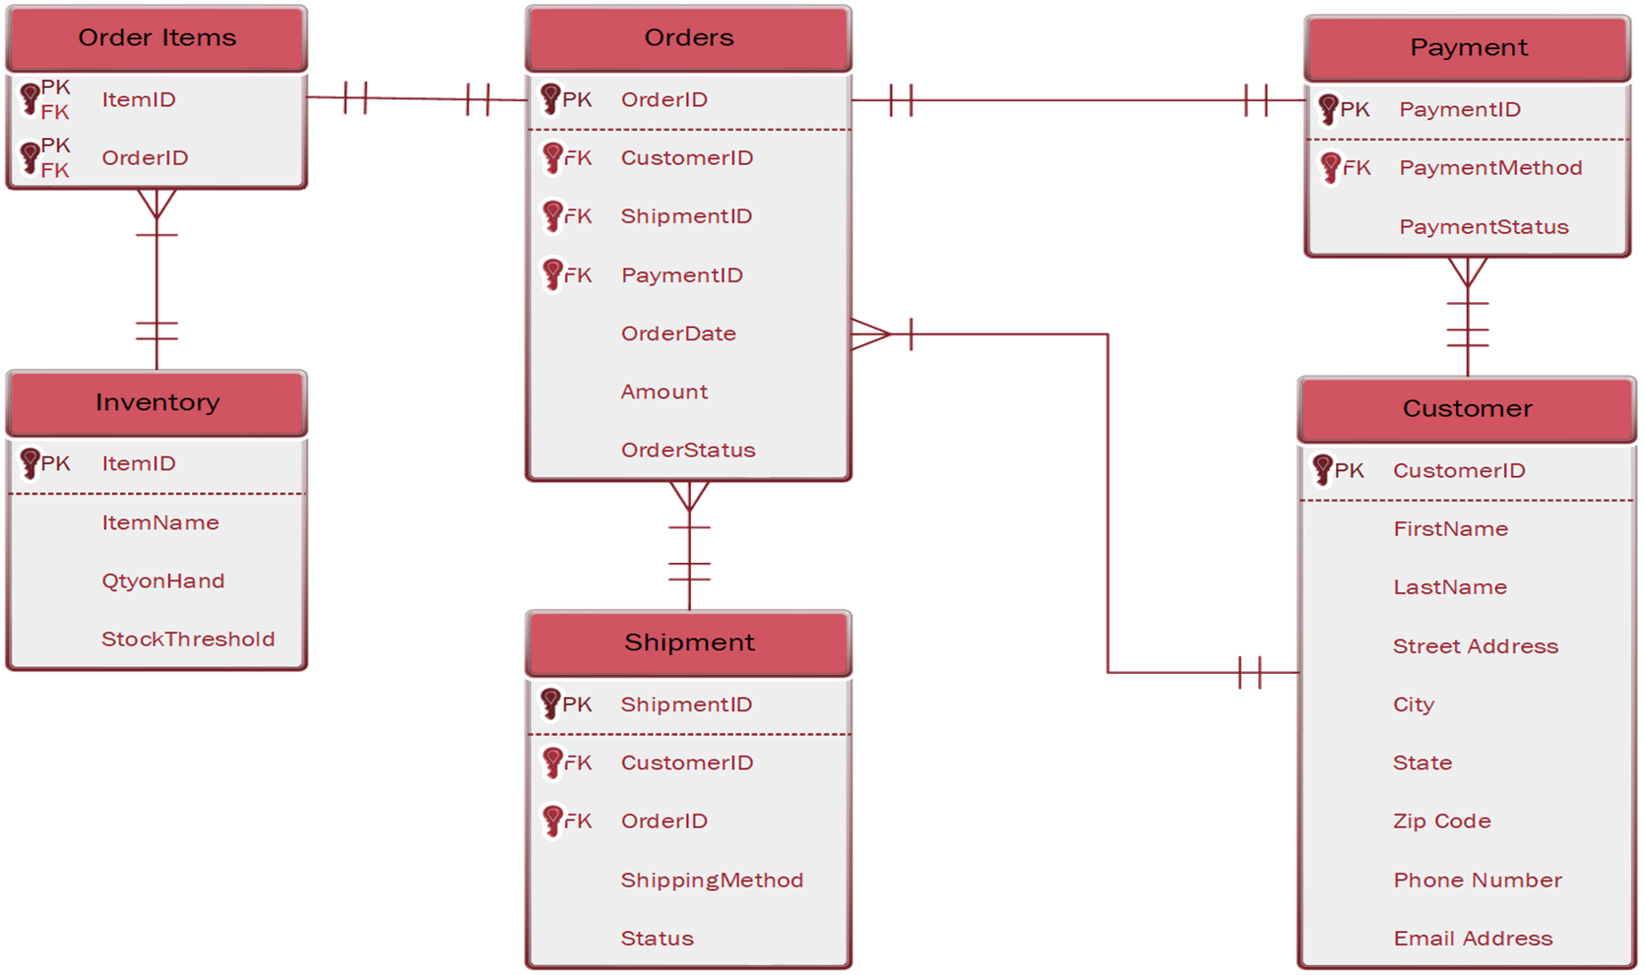

## Program Plan – IPO Chart

|  |  |  |  |
| --- | --- | --- | --- |
| Program | Inputs | Outputs | Processing Steps |
| Home Page | * Orders Table * Shipment Tracking * Inventory Overview | * Order Status * Shipment Tracking * Inventory Summary | 1. Fetch data from Orders, Shipments, and Inventory 2. Aggregate and format data 3. Display results |
| Orders Table | * Customer Name * Item * Payment | * Order History * Order Status | 1. Validate inputs (name, item, payment) 2. Generate unique Order ID 3. Store order in database 4. Update order status |
| Shipment Tracking | * New Orders * Older Orders | * In-transit Orders * Delayed Shipments * Expected Delivery Dates | 1. Retrieve shipping details from the database 2. Calculate estimated delivery 3. Update shipment status |
| Inventory Overview | * Product Stock Level * Supplier Data | * Low Stock Alerts * Restock Notifications * Updated Stock Levels | 1. Check stock levels 2. Generate restock alerts if needed 3. Update inventory database |

## Standard Naming Conventions

# IV.

## Executive Summary with Narrative and Conclusions

## Test Plans

## Training Manual and/or Reference/Procedure Manual

## Technical Manual

# V.

## Executive Summary with Narrative and Conclusions

## Migration Plan (Business, Technical, People Readiness)

## Personal Project Assessment (by each member)

## Lessons Learned during the project (by group)

## Explanation of challenges, problems and discoveries

## All Burndown Charts, All Backlogs, All Meeting Logs

## Any other supporting documentation